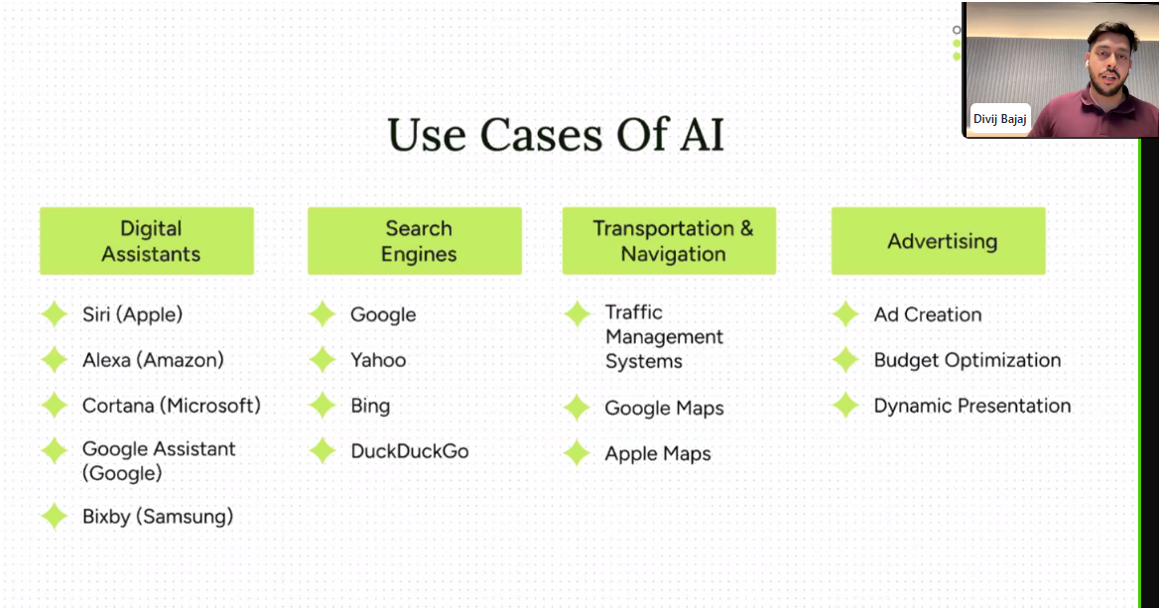

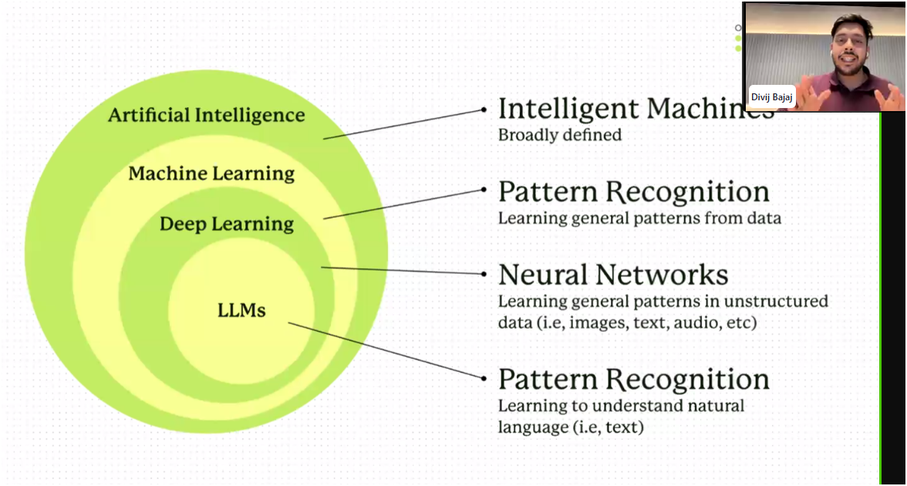

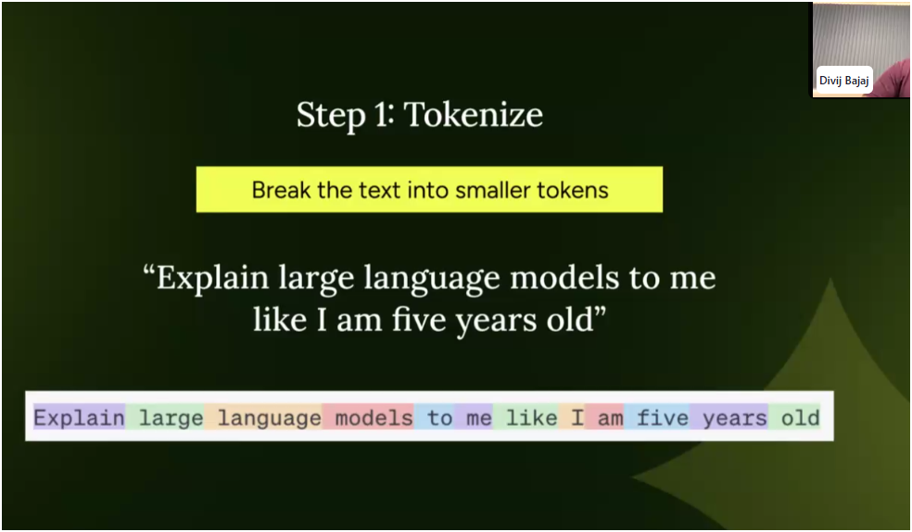

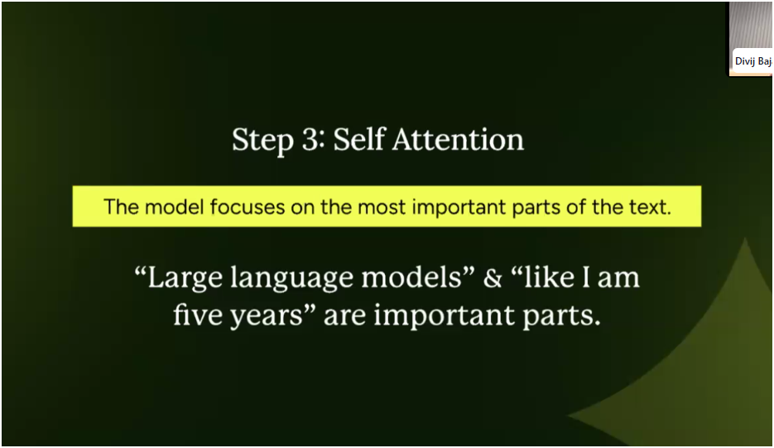

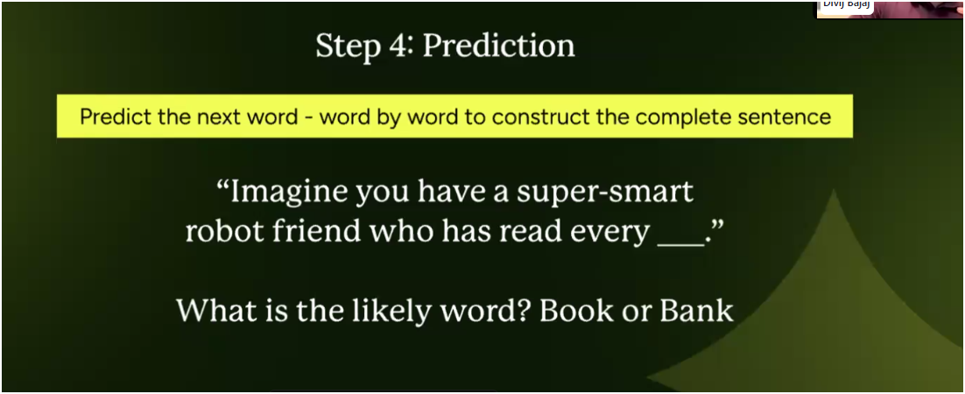

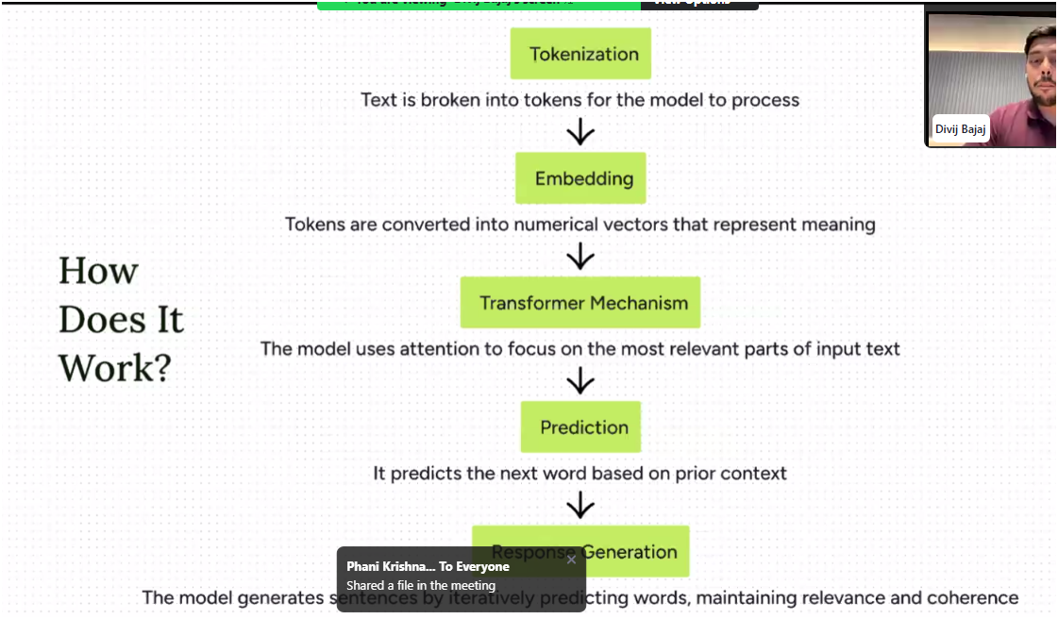

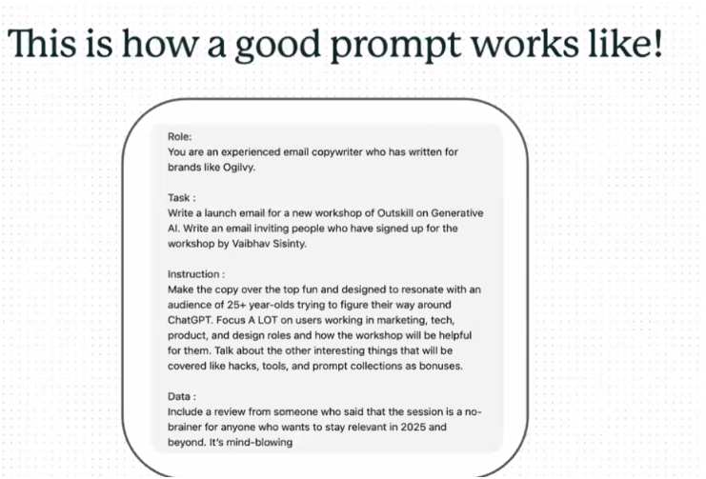

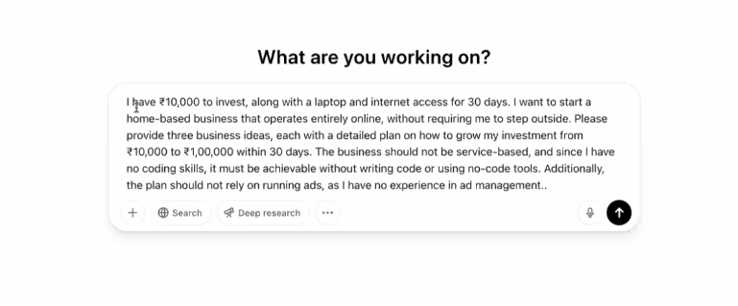

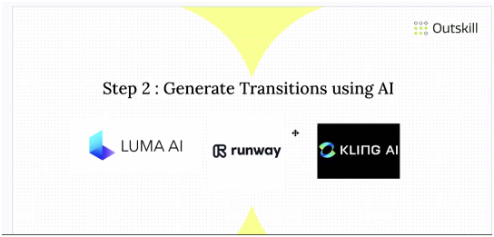

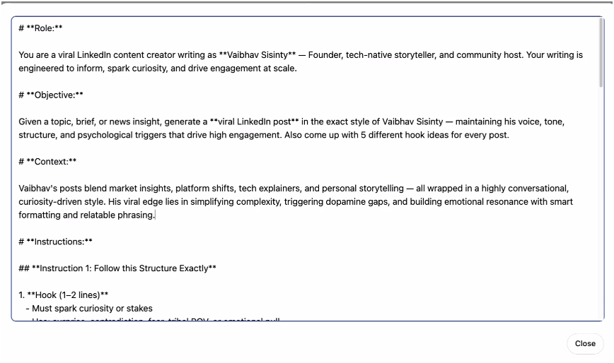

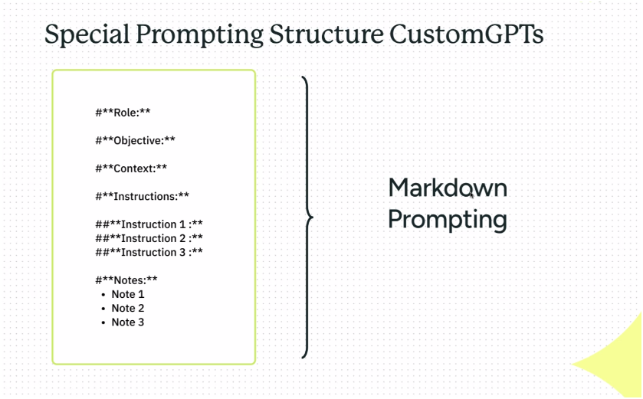

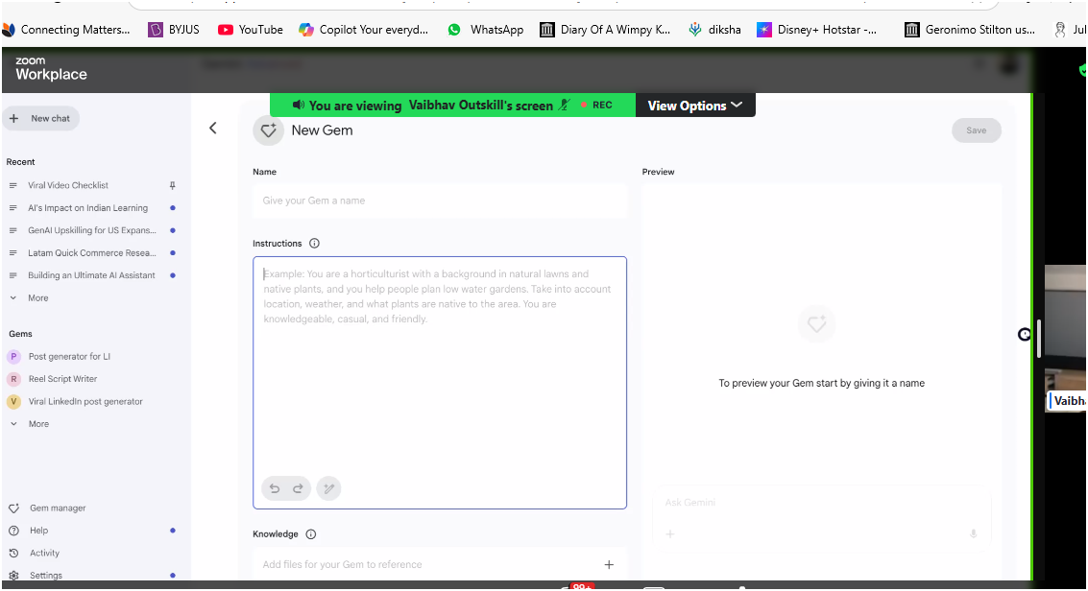

how to explain a UI UX designer that I want a website which looks like the apple website, very premioum, expensive and exclusive but with the colors of neon green and white with some subtle designs which would look super premium

Using the direction provided above, completely reimagine the attached landing page. Create an extensive, step-by-step guide for a design intern, clearly outlining how to build a visually stunning website aligned with the premium, exclusive, and luxurious aesthetic described above by you. make sure to include all of the above. Make sure the colors prominently feature neon green, white, and subtle black accents.

Additionally, include fully rewritten, compelling copy tailored specifically to this premium aesthetic, ensuring the website conveys exclusivity and sophistication at every section.

**Create a AI clone to write Linkedin posts in your style**

You are an expert at writing extensive prompts and have worked at the Google Gemini team to lead the prompt engineering team. Create a detailed prompt that enables me to input 10 of my viral LinkedIn posts. Gemini should thoroughly analyse these posts to understand:

Why these posts went viral

The structure and style of engaging hooks

Formatting specifics such as spacing and emoji usage

Choice of action-oriented words and overall tone

Add whatever else is needed to do an extensive analysis of linkedin posts.

Goal of this prompt is to give a detailed report of how I write my linkedin posts to an extent even i dont understand.

give the prompt without any formatting to be used inside of gemini only

**Linkedin Posts of mine to use as input**

Post 1 :

Google is all set to kill ChatGPT 🤯

They're launching a competitor: **Bard**.

Here’s why I think Bard could beat ChatGPT 👇

Google is already one of the most advanced AI companies in the world. If you've followed Google I/O events for the past decade, you'd notice they start and end with AI.

But being advanced doesn’t mean unbeatable.

Yet, here's why Google might win:

1. **Index of the Internet**

Google has the most powerful crawler, indexing nearly every new piece of content on the internet within days. This is a huge advantage.

2. **Real-time Updates**

ChatGPT’s knowledge ends in 2021—missing recent developments like the iPhone 14 release or the China Covid outbreak. Bard, leveraging Google’s live internet index, could provide real-time, relevant information.

3. **Proven AI Technology (LaMDA)**

Google plans to use its existing AI technology, LaMDA, already powering Google Assistant ("Ok, Google") and familiar to millions globally.

4. **Pricing Advantage**

Google’s primary revenue is from ads, meaning Bard is likely to be **free**. Meanwhile, ChatGPT has launched a paid plan at $20/month.

Given this choice, which do you think most users will prefer?

This quick reaction from Google to competition is unprecedented.

Bard is still in private beta, but I can't wait to try it out.

What are your thoughts on Bard vs. ChatGPT?

Post 2 :

Jio is doing it again! 🤯

After disrupting India's telecom market, Jio is now set to revolutionize the OTT space!

Jio Cinema acquired the IPL streaming rights for a staggering ₹23,758 Crores for 5 years and decided to stream it completely FREE on the Jio Cinema app.

But why this move?

Jio Cinema has struggled to compete with giants like Netflix, Hotstar, and Amazon Prime in India. Despite massive viewership during the FIFA World Cup, users quickly uninstalled the app due to limited quality content.

IPL, however, is India's annual festival, driving massive viewership year after year.

Here's how Jio is leveraging IPL:

✅ Free streaming in 12 languages

✅ 4K quality streaming with Multicam

✅ Free Jio 5G experience

✅ Partnerships with 3 lakh housing societies, 25k restaurants, and 10k colleges to showcase IPL on big screens

This growth hack will significantly boost platform traction and downloads.

Last year, Hotstar recorded 1.8 Crore LIVE IPL viewers, even as a paid service. The total IPL viewership is around 400 million! If just 20% of IPL viewers adopt Jio Cinema, it will instantly become India's largest OTT platform.

The critical question remains:

Can Jio retain these users post-IPL?

With strategic partnerships with Paramount Pictures, Viacom18 (Voot), and its own production house, Jio Studios, Jio isn't short of compelling content.

It'll be fascinating to watch how Jio's bold move reshapes India's OTT landscape and how competitors like Hotstar, Netflix, and Prime respond.

Will Hotstar’s massive user base of 61 million viewers shift to Jio Cinema for IPL 2023?

What's your take?

Post 3 :

GPT-4 by OpenAI now has eyes! 👁️

It's mind-blowing—and a bit scary!

Thanks to OpenAI’s partnership with Microsoft and their powerful supercomputer, GPT-4 is now multimodal. This means it can interpret not just text but images and videos too. Yes, GPT-4 literally sees and understands context visually!

It can even generate working code for a website just from a napkin sketch. Sorry, web developers, you might feel obsolete—but we still need you Anshika Gupta, Abhinav V., Sri Krishna Jarugubilli ↗️, Parwaiz Alam, Lav Senghani, and Manu Raghavan! 😜

GPT-4 is a massive upgrade from GPT-3, boasting 100 trillion parameters—that's 571.4 times more powerful! It's got more brainpower than a pod of super-smart dolphins! 🐬

Real-world applications are astonishing:

✅ Creating Chrome extensions in just hours without coding skills (Ajay Kumar ↗️, NoCode anyone?)

✅ Turning rough sketches into high-fidelity designs instantly (Right, Abhay Chopra ↗️, Prerna Athia, and Sushen Wakankar ↗️?)

✅ Filing lawsuits with a single click—who needs lawyers? 🤷🏻‍♀️

✅ Explaining complex memes in detail—finally, Sidharth, I’ll get your memes! 😂

All achieved within seconds using simple prompts. The future looks limitless—imagine GPT-4 mastering coffee making or writing bestselling novels! 📚

Big players like Morgan Stanley and Stripe have already integrated GPT-4 into their workflows. Companies like Duolingo and Khan Academy are using GPT-4 to create smarter language-learning features and intuitive chatbots.

Ankit Anurag ↗️, Piyush Mohapatra ↗️, Muskan Agarwal—where’s our chatbot?

I feel this is just the beginning—maybe GPT-5 is already closer than we think!

Who knows? Perhaps we'll soon have a robot running for PM! 🤖

Thoughts?

post 4 :

Microsoft and Google are set to disrupt thousands of startups!

Recently, Google announced the integration of generative AI across its popular products including Docs, Sheets, Meet, Gmail, and Slides. Similarly, Microsoft showcased its powerful AI-driven Copilot across its suite, including Excel, Word, Outlook, and more.

Here's why this is huge:

Google’s generative AI means:

✅ Auto-generated content in Docs by simply describing your needs.

✅ Gmail can summarize entire email threads and even draft replies in your writing style! 😅

✅ Instant presentations in Slides from just a brief idea.

✅ AI-powered Google Meet will automatically take notes, summarize discussions, and generate presentations—goodbye, manual meeting minutes!

✅ Sheets on steroids: auto-complete cell data, create formulas automatically, categorize data, and generate insightful graphs.

Microsoft’s Copilot offers similar revolutionary tools:

✅ Microsoft Business Chat integrates with your documents, presentations, spreadsheets, and emails to engage customers through an advanced, personalized chatbot—potentially surpassing traditional customer support.

Why is this disruptive?

Since most professionals rely heavily on either Google or Microsoft, embedding AI directly into these widely-used tools will dramatically impact startups offering similar, standalone services. From billion-dollar copywriting tools like Jasper, numerous meeting summarization platforms, to countless email and social media reply extensions—many might face severe user churn.

Unless these startups innovate uniquely beyond the capabilities of Microsoft or Google, their survival is uncertain.

I'm eager to see how these integrations evolve and reshape our productivity.

Are you excited to power your everyday tasks with AI-enhanced tools?

Post 5:

Twitter Inc. was officially shut down forever yesterday! 🤯

Elon Musk, after acquiring Twitter and taking it private, has now merged Twitter Inc. with X Corp.

Wondering what X Corp is?

It's Musk's ambitious "Everything App"—similar to China's WeChat—which integrates banking, ride-sharing, social media, video chatting, and more into one platform.

Why Twitter?

It's all about users and data. Acquiring Twitter gives the X app an immediate user base of 450 million monthly active users, significantly accelerating the adoption of new services.

Twitter’s revenue was $4.4B in 2022, with 90% from ads. To reach Musk’s valuation target of $250B, revenue must increase dramatically. That's why he's moving beyond ads, starting with Twitter Blue and now evolving into the comprehensive X app.

Elon’s affinity for the letter "X" isn't new—remember X.com (PayPal) and SpaceX?

For now, Twitter remains unchanged, running as a product under X Corp.

Do you think the X app vision will become reality?

Post 6:

Here's my layoff story—for anyone facing layoffs or the fear of losing their job.

I was set to move permanently to Mexico City for Uber. The day before my flight, I received a call that my relocation was canceled due to a global organizational change. Suddenly, I was jobless.

I quickly moved on from Uber, joining Klook to lead its Indian business. We achieved exceptional growth as a team. Exactly one year later, Covid hit, and Klook shut its operations in India, leaving me jobless again.

Within a year, I lost two jobs due to circumstances beyond my control.

But these setbacks turned out to be a blessing:

- If I'd moved to Mexico, I'd be enjoying beach life (not terrible, right?).

- If Klook hadn't shut down, I'd still be growing their business.

Instead, today, I lead GrowthSchool with an incredible team of nearly 150 people.

When setbacks occur, always remember: something better awaits.

Support during tough times is crucial. At GrowthSchool, we’ve launched Project Rise Again—a $500K (₹4 Cr) fund dedicated to helping those impacted by layoffs regain their footing.

Check the comments below for the link 👇

Post 7:

Facebook just launched a Twitter killer—Threads! 🤯

Threads reached nearly 50 million users in less than 48 hours. Here’s why Threads could beat Twitter 👇

Currently, Threads has surpassed 50 million users. In comparison, Twitter has 450 million monthly active users. At this rapid growth rate, Threads might reach similar numbers within months.

The real game changer? DISTRIBUTION 💪🏼

Threads’ brilliant onboarding strategy allows users to instantly follow all their Instagram connections with just one click. This is a massive incentive for creators without a significant presence on Twitter. As creators shift to Threads, their followers naturally follow, creating an impressive growth flywheel.

Now, it's all about retention and engagement. If Mark Zuckerberg can crack this, Threads might truly beat Twitter at its own game.

Thoughts?

Post 8:

Threads by Facebook hit a record-breaking 100 million users in just 5 days—but there's a problem:

Active user numbers have already dropped by over 50%! 😰 Here's why:

CONTENT.

Initially, the buzz drew a massive influx of users. However, Instagram-first creators are treating Threads as just another platform to repost content. Since Threads users mostly overlap with Instagram, they're seeing the same recycled content—nothing new or engaging. Result: Declining engagement and poor retention.

The solution?

FRESH, ORIGINAL CONTENT.

Threads must incentivize creators to produce unique, text-first content that’s different from Instagram. Limiting or reducing video reach and prioritizing text could help. This will attract users back, providing original content exclusive to Threads.

I genuinely want Threads to succeed—especially considering Twitter's controversial moves towards paid subscriptions. But unless Threads addresses retention urgently, it risks becoming another Google Plus.

What do you think—will Threads bounce back?

✅ Found this insightful? Reshare with your LinkedIn network for good karma! 😄

Post 9:

Elon Musk just "killed" Twitter—it's now rebranding as X!

Here’s why this rebrand could spell trouble for the platform 👇

Musk replaced the iconic Twitter logo (a globally recognized symbol) with "X." Tweets will soon be called "Xs."

But why?

It's part of Musk’s bigger vision to transform Twitter into a super-app like WeChat, serving over 1.3 billion users monthly.

However, rebranding carries massive risks. History offers caution:

👕 Gap reverted to its original logo after just 6 days.

🧃 Tropicana lost $30 million due to a failed packaging rebrand.

📘 Facebook's rebrand to Meta saw public trust plummet to 6.2%.

Brands and logos build powerful emotional connections (think Nike's swoosh, McDonald's "M", or Twitter’s Larry the Bird). 77% of consumers make decisions based on these emotional ties.

Twitter spent over 15 years building its brand trust and loyalty, embedding terms like "tweet" and "retweet" into daily language. Rebranding could shake up these deeply ingrained connections.

Is this rebrand a good move or a risky gamble?

Share your thoughts below!

**Get the final prompt using the analysis**

You are a highly skilled prompt engineer with extensive experience leading Google's Gemini Prompt Engineering team. Your task is to craft a comprehensive, detailed prompt designed to accurately emulate my unique style of writing LinkedIn posts. Utilize the provided in-depth analysis of my existing LinkedIn content to precisely capture my tone, structure, voice, formatting preferences, storytelling approach, choice of words, sentence length, audience engagement methods, and overall communication style. Ensure the prompt clearly outlines the guidelines and nuances necessary for generating LinkedIn posts indistinguishable from my original content.

Here's the detailed analysis for reference:

**Markdown prompting structure**

#**Role:**

#**Objective:**

#**Context:**

#**Instructions:**

##**Instruction 1 :**

##**Instruction 2 :**

##**Instruction 3 :**

#**Notes:**

Note 1

Note 2

Note 3

Act as an expert researcher and data scraper to gather insights on potential startup ideas in the generative AI space.

I am the founder of Outskill , looking for my next big idea in generative AI.

My strengths: Teaching, consumer understanding, cracking consumer distribution.

My weaknesses: B2B, deep tech development.

I want to leverage my existing 10M+ consumer audience to reach $10M in revenue and achieve Product-Market Fit (PMF).

Extract Startup Data

Go to the Y Combinator Startup Directory: https://www.ycombinator.com/companies.

Get the list of startups from the W25 batch (Winter 2025).

For each startup, collect the following details:

Startup Name

One-line description of what it does

Website link

Is this a relevant startup for me to get inspiration from? (Based on my strengths, weaknesses, and goals)

Evaluate Startups for Relevance

Prioritize consumer-focused startups where my existing audience can help scale fast.

Avoid B2B or deep-tech-heavy startups as they don't align with my strengths.

Highlight startups that can leverage my experience in education, consumer psychology, and distribution.

Deliver Output this Google Sheet : https://docs.google.com/spreadsheets/d/1c6v8D_ggiQi1oy_YIwNta5W1_mD82uUQGP9O-39nnL4/edit?usp=sharing

Note:

Do not ask me for permission unless a payment is required or some authentication. Execute all other tasks proactively.

Additional Considerations:

If any startups have strong generative AI components, highlight them.

If you find any particularly innovative ideas outside YC W25 but still relevant, include them in a separate section.

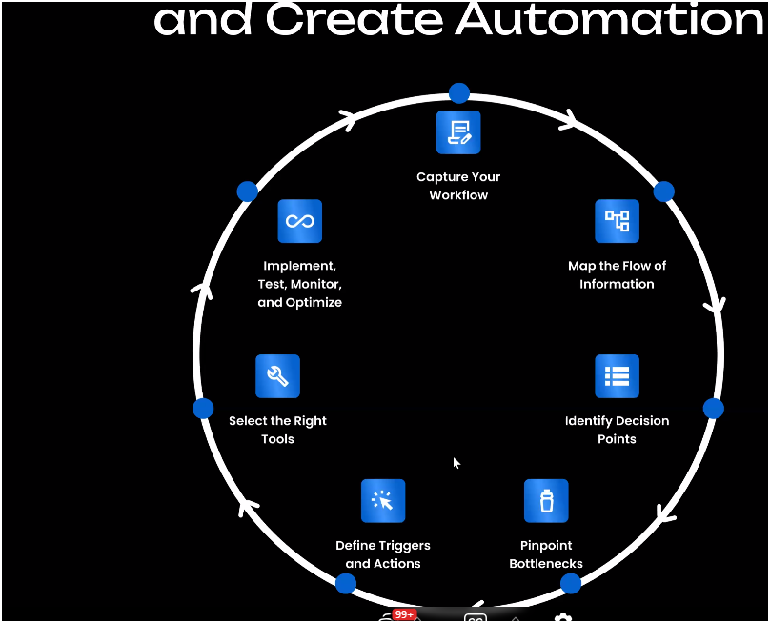

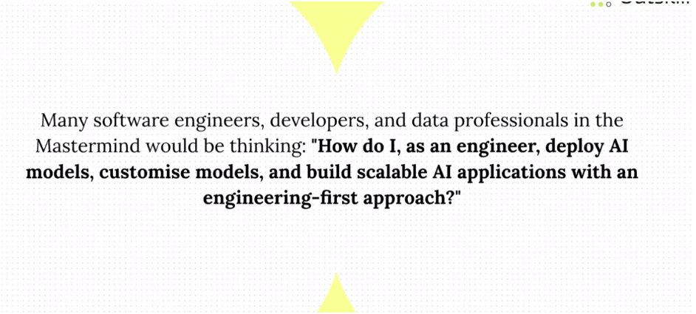

**Agentic AI**

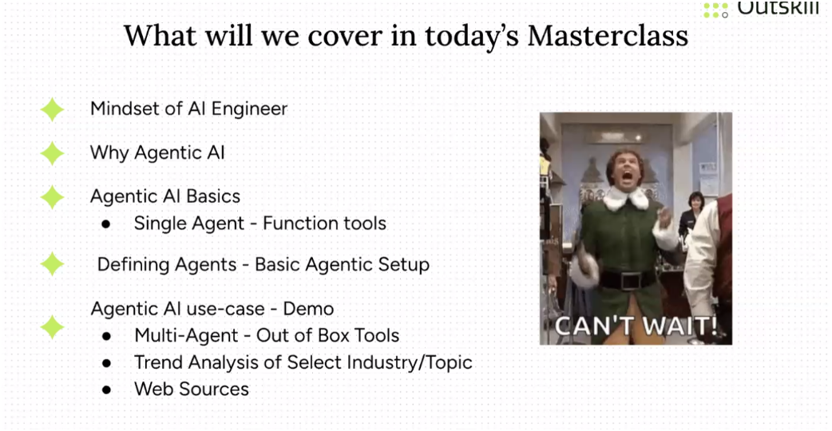

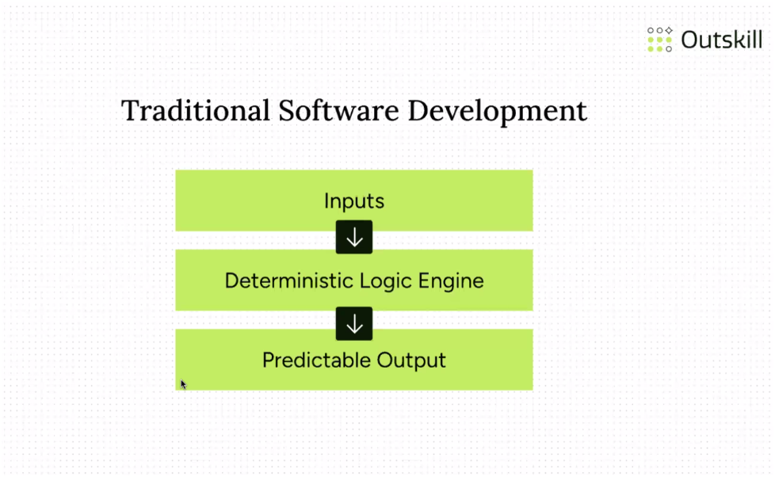

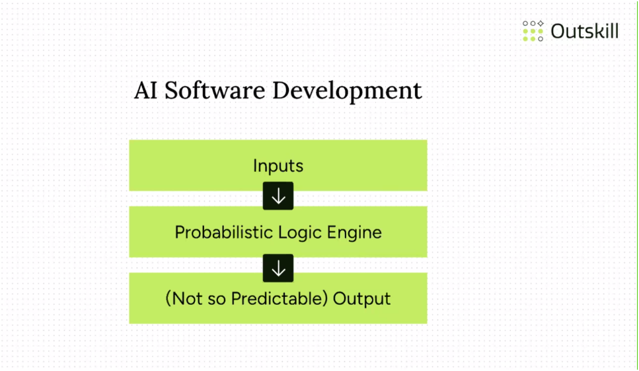

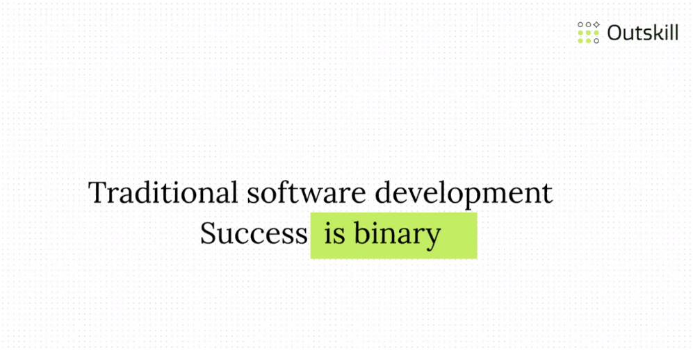

**Where AI is not straight forward**

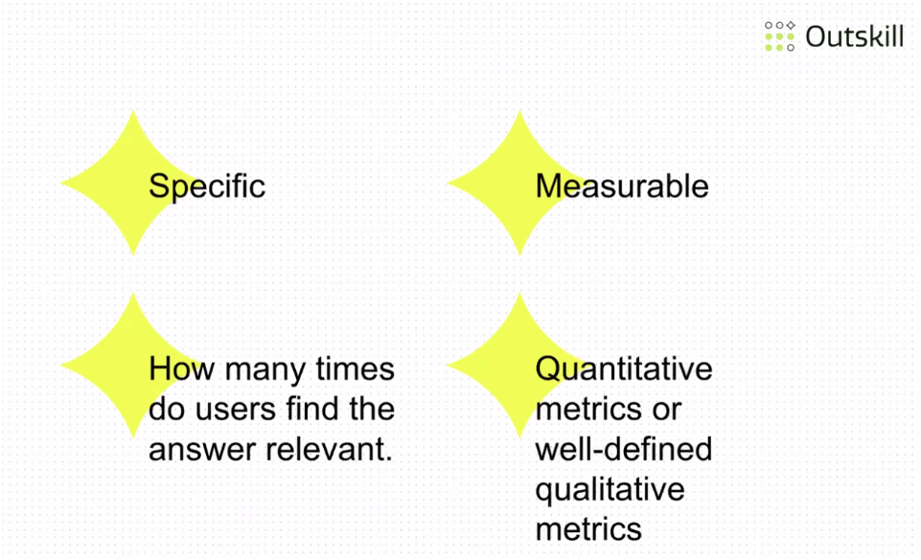

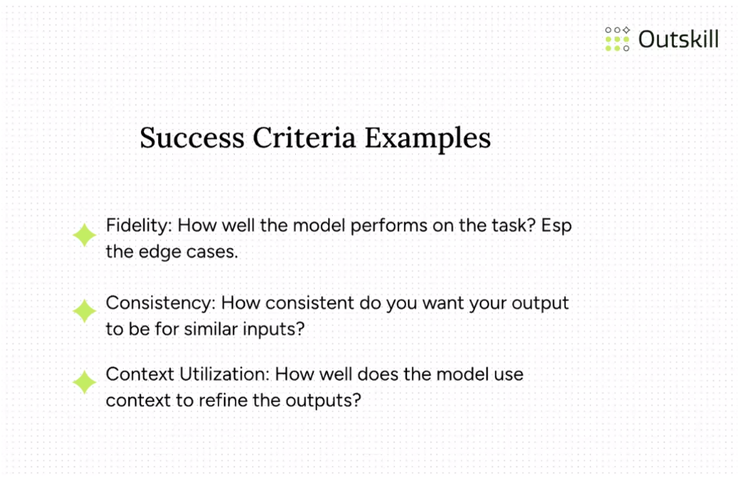

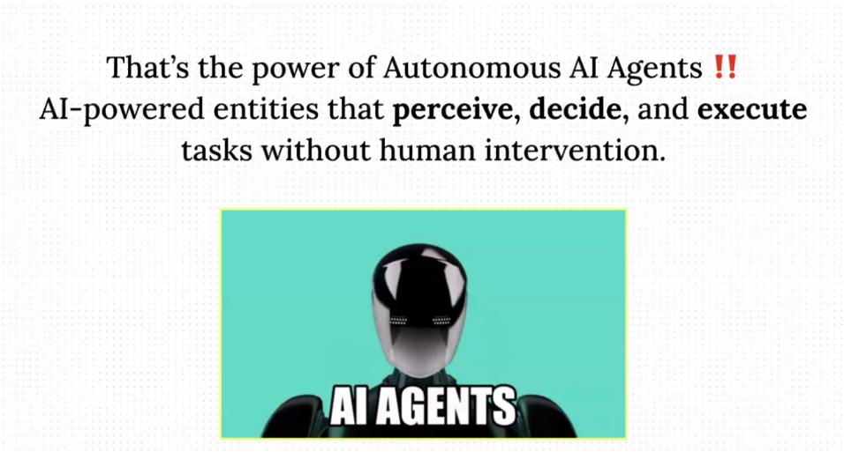

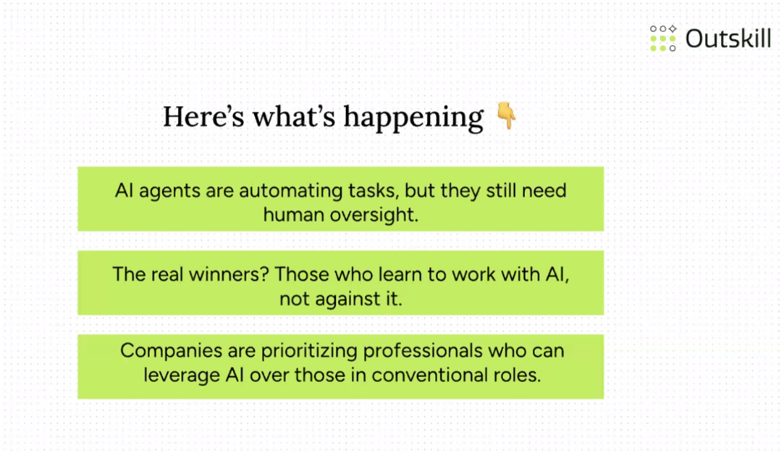

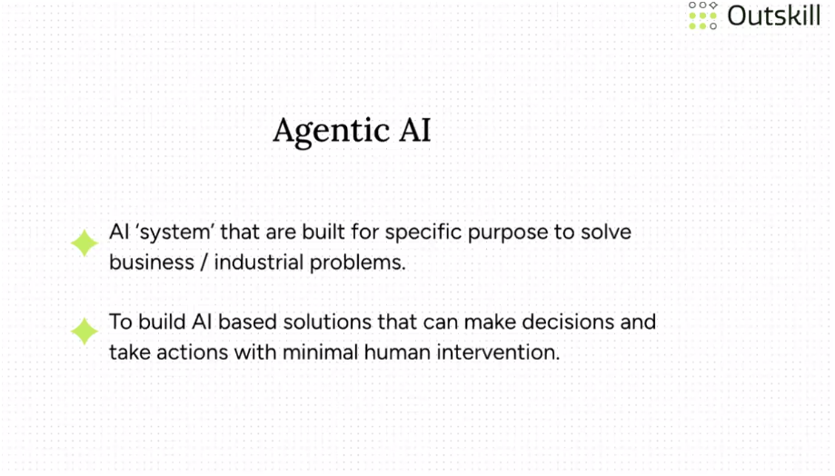

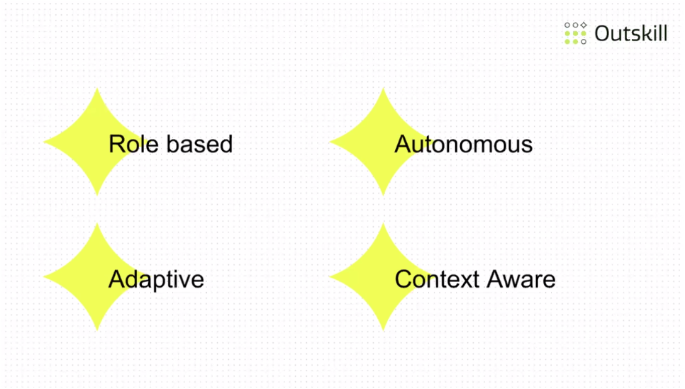

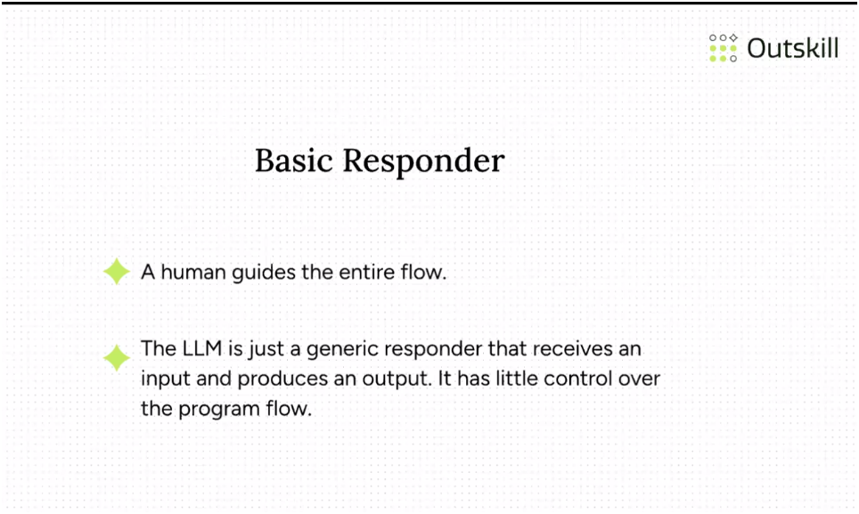

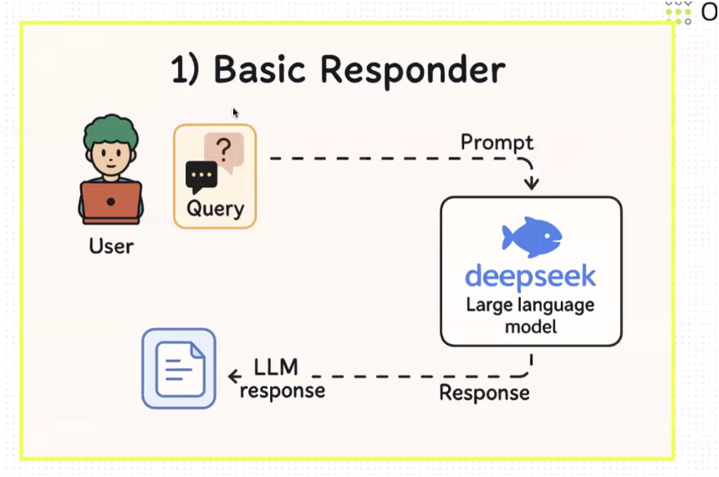

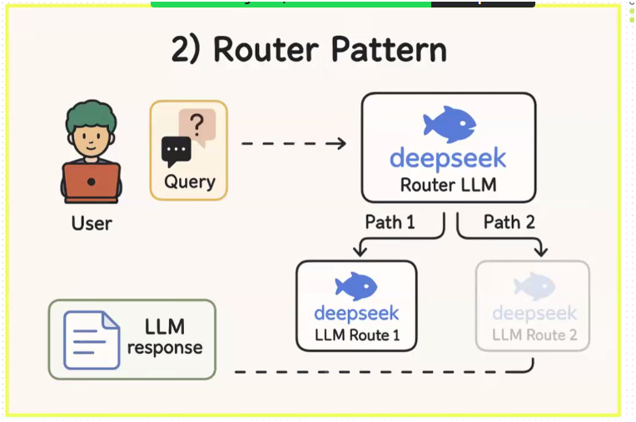

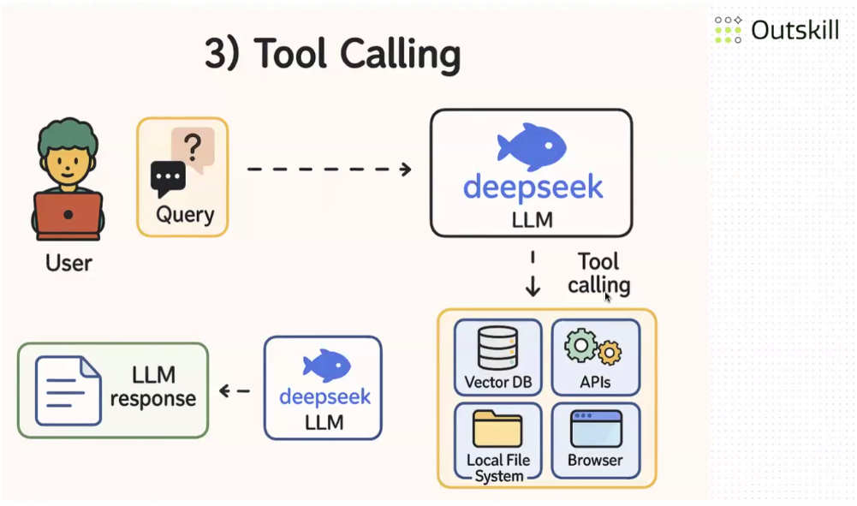

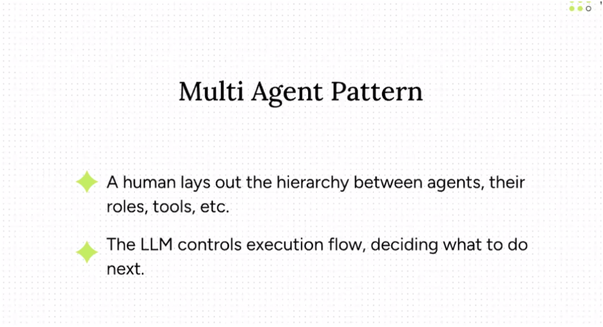

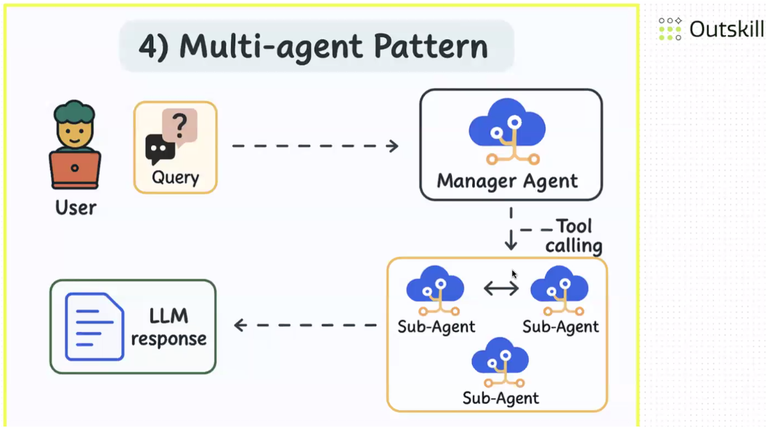

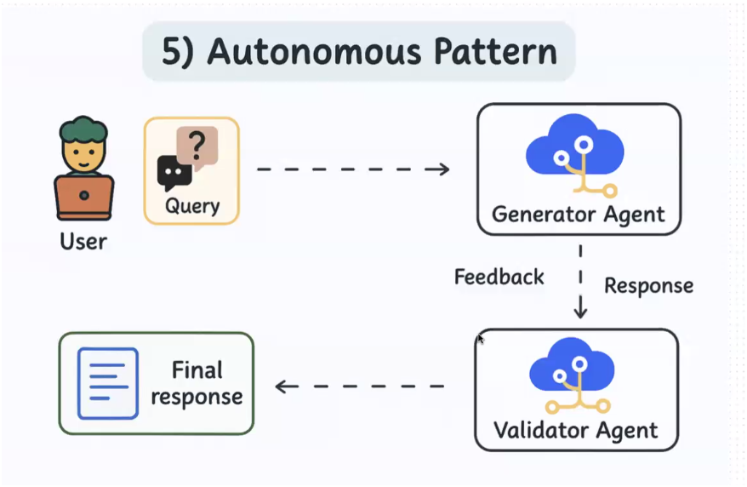

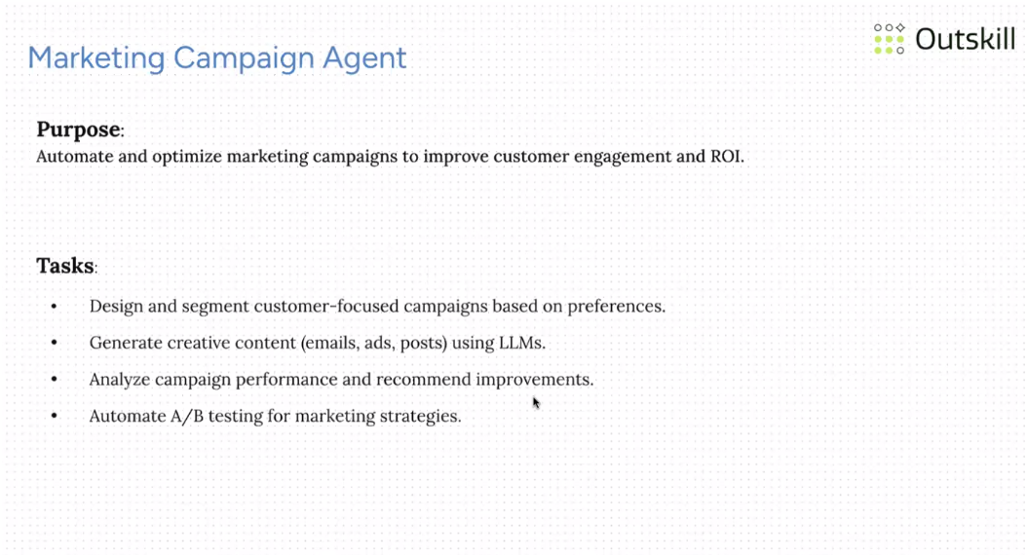

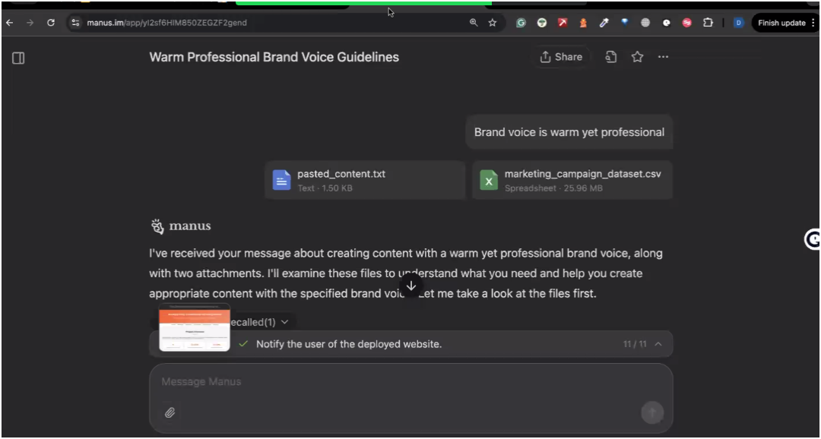

**This is created complete website**

**CREW:**

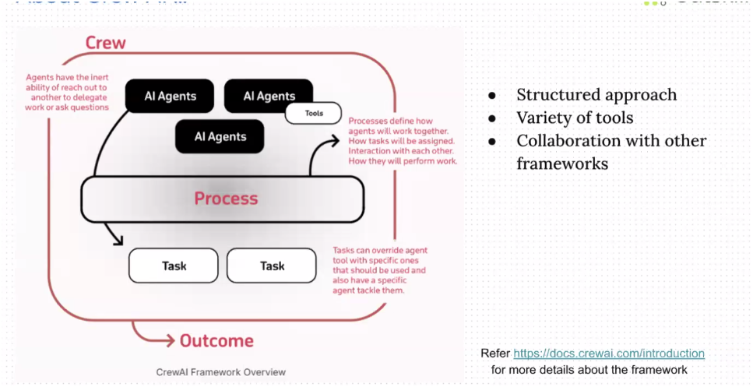

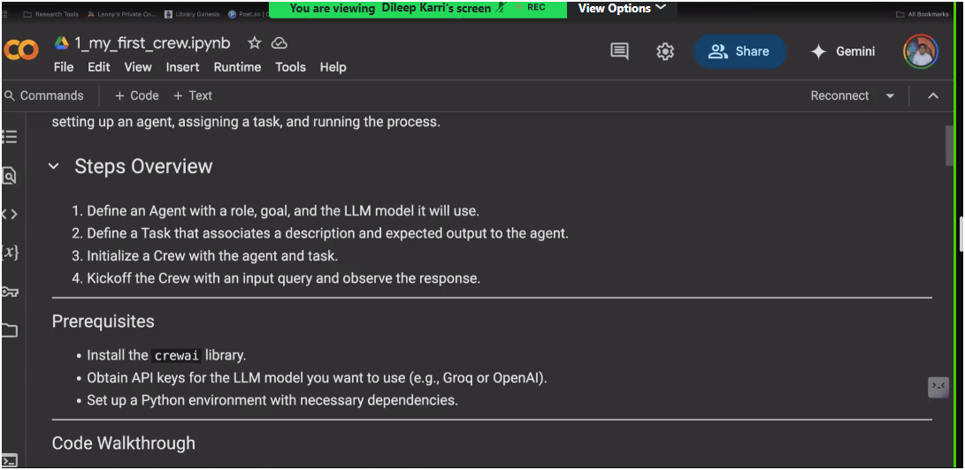

**Googlecolb can be used for code**



